Yule–Simon distribution

Def

PDF

=

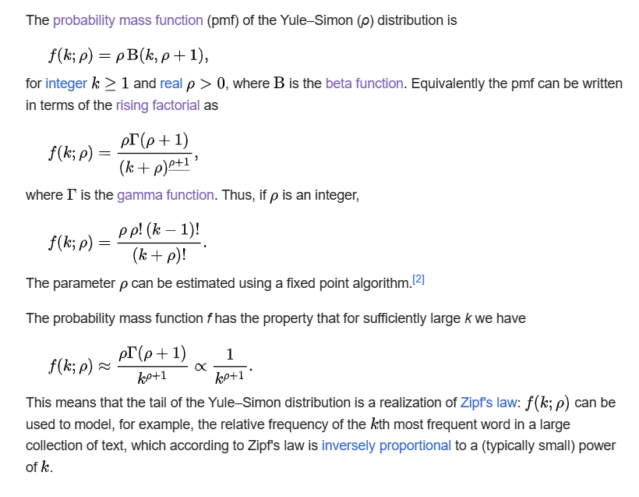

CDF



Expected Value



Variance



Mode



Skewness



Ex. kurtosis



MGF



CF



Ref

[Yule–Simon distribution - Wikipedia](https://en.wikipedia.org/wiki/Yule%E2%80%93Simon_distribution)